Publicity

Ways to publicize the Growing in Faith/diakonia program in your area:

Page on your synod website

Information nights- in person or via internet

Display/kiosk at synod events

Distribute flyers to congregations

Temple talks by diakonia grads or pastors, synod staff

Direct invitation of prospective students (recommended by pastors, synod leaders, etc)

Digital announcements in congregational and synod communications

(find more info and samples at national website URL)

GIF/Diakonia logo
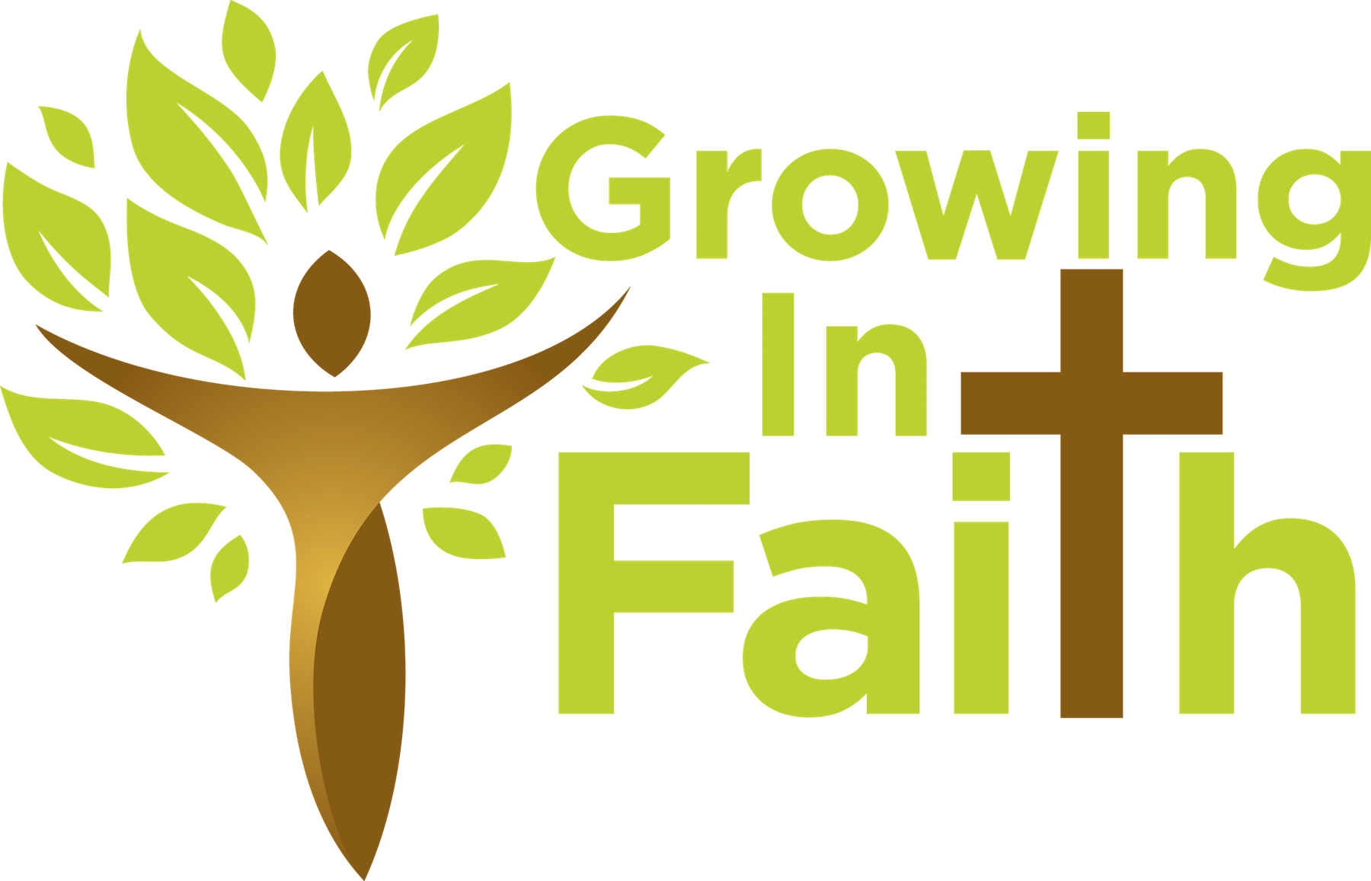

The diakonia logo is found at http://www.diakoniausa.org/resources/branding/
Use the logo and color palate on all diakonia communications, printed and digital.

Sample Bulletin Announcements
Growing in Faith/the (synod name) diakonia program students are committed to serve through the Church in a variety of ways: teaching, administration, liturgical leadership, action for social justice, evangelism, visitation of the sick, community organization, youth work, ministry among the elderly, and the like. In every way, they seek–and are helped by GIF/diakonia–to grow closer to the image and example of Christ the servant. For further information, please contact (Name Here) at (Phone number here) or go to ww.thediakoniaprogram.org

Growing in Faith/the (synod name) diakonia program is a faith formation program for laity. GIF/diakonia emphasizes the vocation of all Christians to serve as Christ has served us. Anyone interested in this opportunity to enhance their Christian education and equip them for ministry and service to the church is encouraged to contact (Name Here) at (Phone number here) or go to www.thediakoniaprogram.org

Growing in Faith/the (synod name) diakonia program is designed to prepare Christians to fulfill their baptismal calling as servants of Christ. This two-year series of 12 courses, taught by local pastors or experienced instructor/pastors online, offers solid theological instruction. For further information, please contact (Name Here) at (Phone number here) or go to ww.thediakoniaprogram.org

Growing in Faith/The (synod name) diakonia program is a two-year process of theological education and spiritual formation. It assists students not only with academic training, but with group interaction, spiritual retreats, and an opportunity to assess their God-given gifts and how best to apply them. For further information about this two-year theological program for lay persons, please contact (Name Here) at (Phone number here) or go to www.thediakoniaprogram.org

